1. 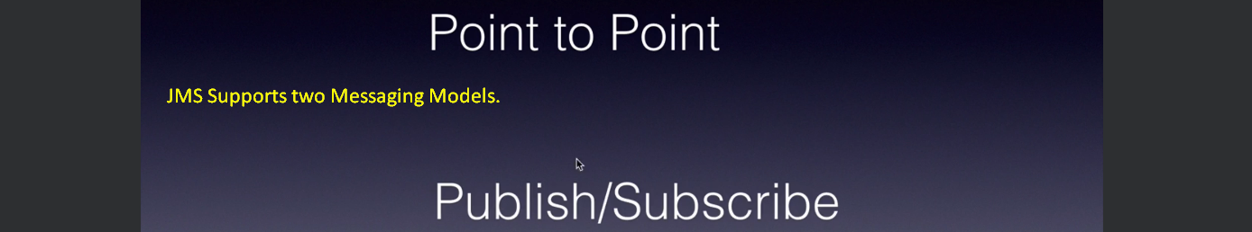
2. **Point-To-Point**:
   1. Also known as **Peer-to-Peer** (P2P) **Messaging** allows us to send/receive msgs both **synchronously** and **asynchronously** through **virtual channel called Queue**.
   2. **JMS Provider** (ActiveMQ, WebSphere MQ etc) allows us to create such queue.
   3. **App** sending msg is called **Producer** and the app receiving the msg is called **Consumer or Receiver**.
   4. One distinguished feature of P2P Messaging is that msg put on the queue can be consumed only once and by only one app.
   5. P2P Messaging provides “**Async Fire and Forget**” that is an app (Producer) puts the msg on the MOM and forgets and the Consumer app whenever it wants can get the msg and process it.
   6. It also supports **“Synchronous Request/Reply Messaging”.**That is an app A puts msg on the queue and waits for the response on other queue as Consumer App will put the response msg on some other queue.
   7. Analogy to P2P is when we send a Greeting Card which is sent to only one person.

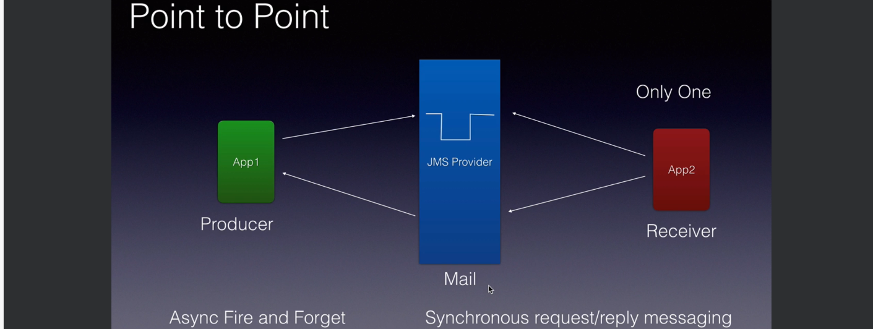

1. **Publish/Subscribe**:
   1. Also known as Pub-Sub Model which is a PUSH Model as when a msg arrives it is pushed to each subscriber by the JMS Provider (ActiveMQ) without consumer having to poll or request for the msg.
   2. 